RFID Hall Pass – Final Project

Christopher Yang, Lautaro Stamati

Week 2 – 4/25/2025

Executive Summary:

- We’ve attempted to finalize the code with four distinct versions, running all of them various times. Reading and writing strings to the RFID has been a task we haven't been able to complete, however.

- No significant changes have been made to the wiring, and code-wise we’re trying to embed a string that dictate a tag’s UID, location, and other data. When we implement 2+ devices, one device will become a “master”, redirecting all signals to its serial output, while the other devices merely detect.

Schematic:

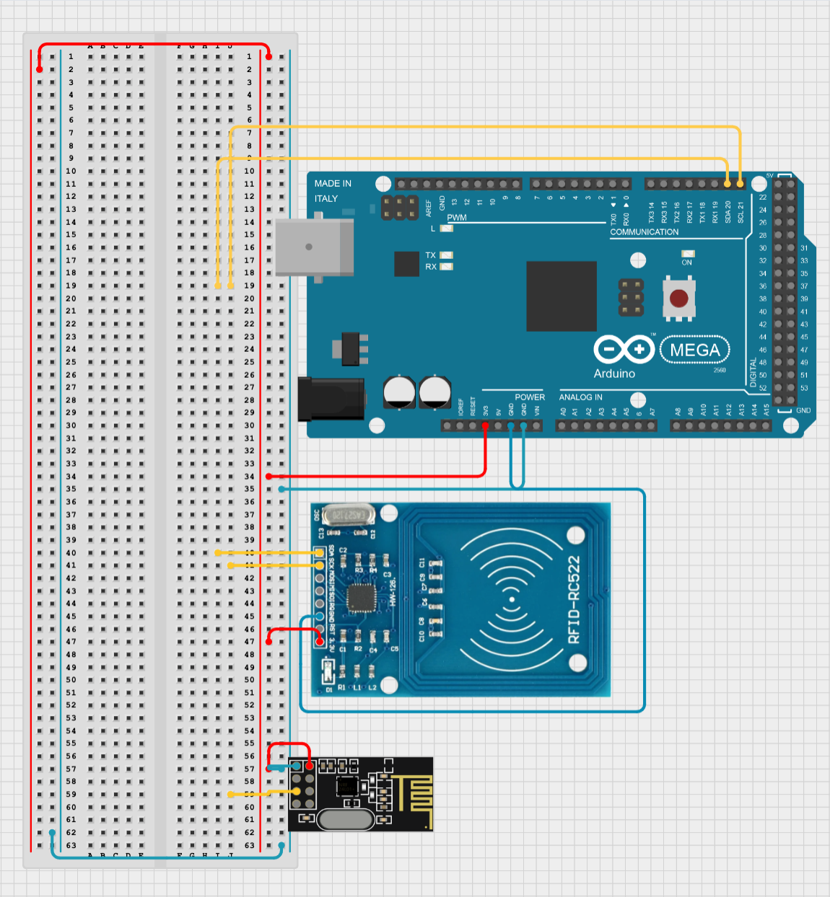

Gantt Chart & Planning:

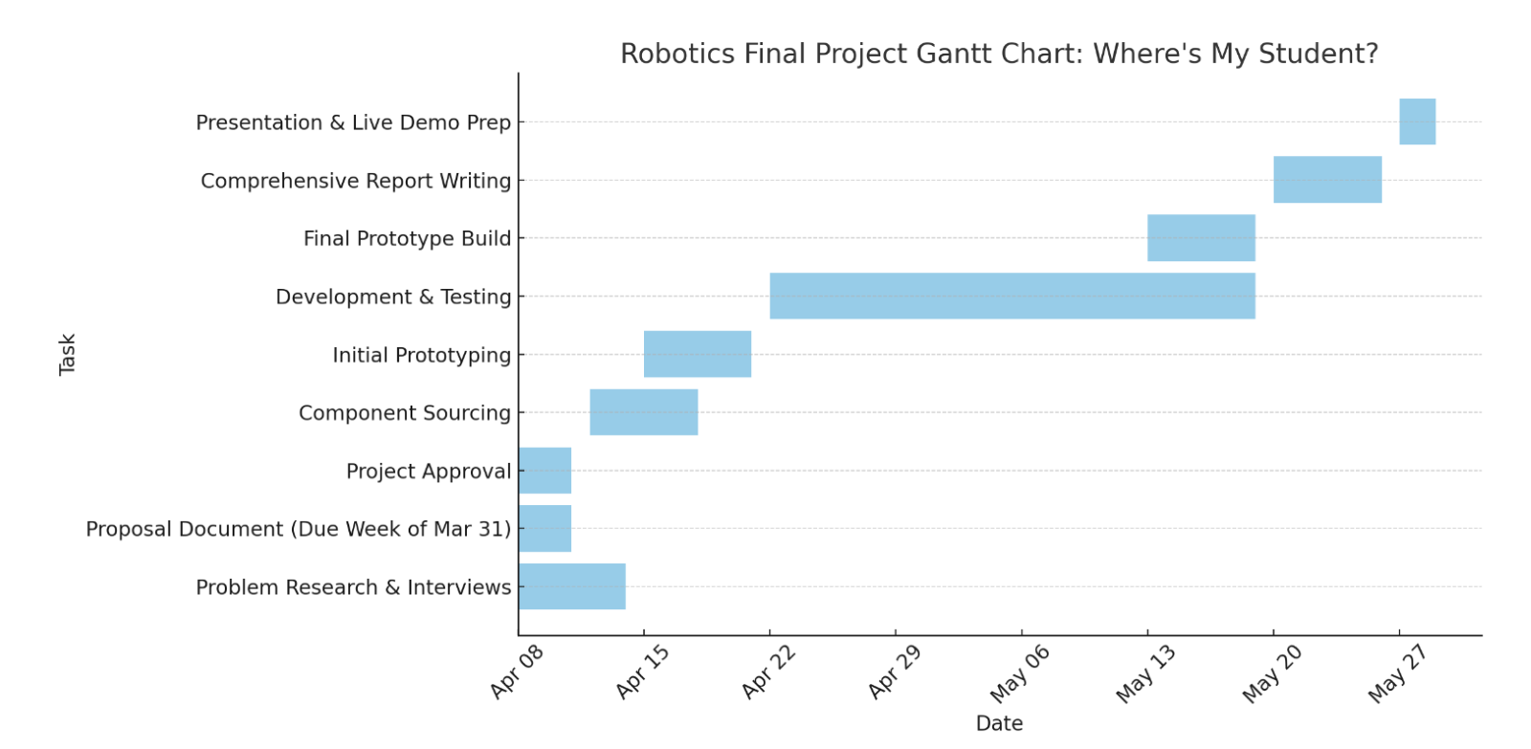

- Next week, the team’s goal is to finish writing/reading data, and to implement a device system on separate breadboards. After that, we can work on adding more cards or on the wireless system.